Print MSPN Label
- Login to WMS
- Under *Choose responsibility*
- Choose XXWMS Warehouse User - N.A.
(Could be under a different number for you)
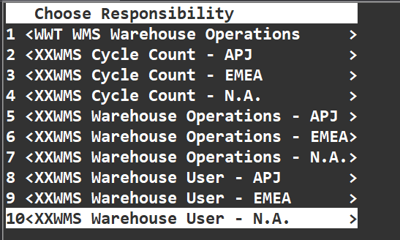

- Go to <Others>
- Go to <Label Printing>
- *Org Code* <40>
- For *Printer* enter <NAIC1-107>
You should now be on this screen:
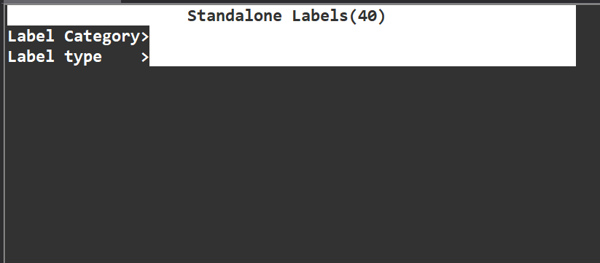
- Hit <F4> on *Label Printing*
- Select <LAB>
- Hit <F4> on *Label Type*
- Select <Data Capture>
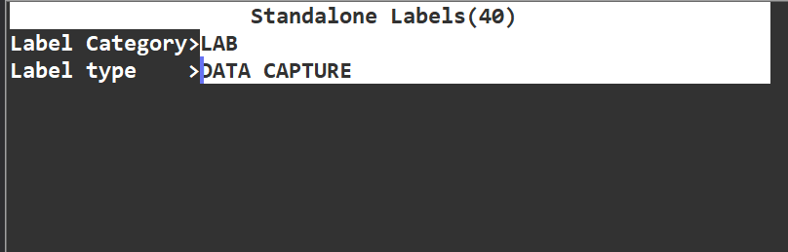
- For *Line of Buisness* type in <MSPN>
- Your *Part Number* can be found on MES as your “Finished Good” found here:
( Use the entire 4-Segment Part Number )
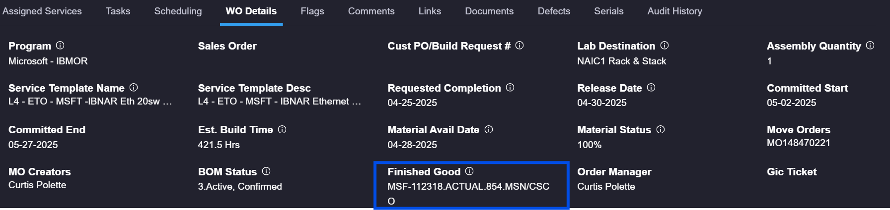
- For *QTY* enter <1> as we will do this per rack
- Hit *Done* and grab your MSPN Label
Incorrect
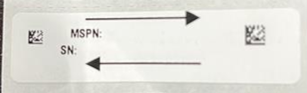
Correct
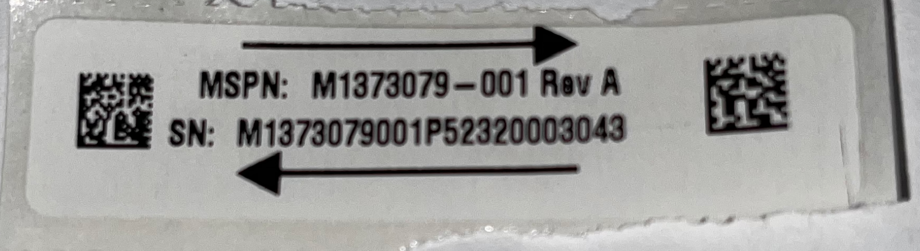

ADVISE
MSPN Revs are dependent on change at any time by Microsoft
please refer to admins updated document on the MSPN Rev types Per Build

This instruction was created by Benjamin Cullum

